GIT RELATED TASK – GRAD HIRES

Create a repo on GitHub

Clone it into your local system

Add a file in that directory

Add, Commit and Push it to the remote repo

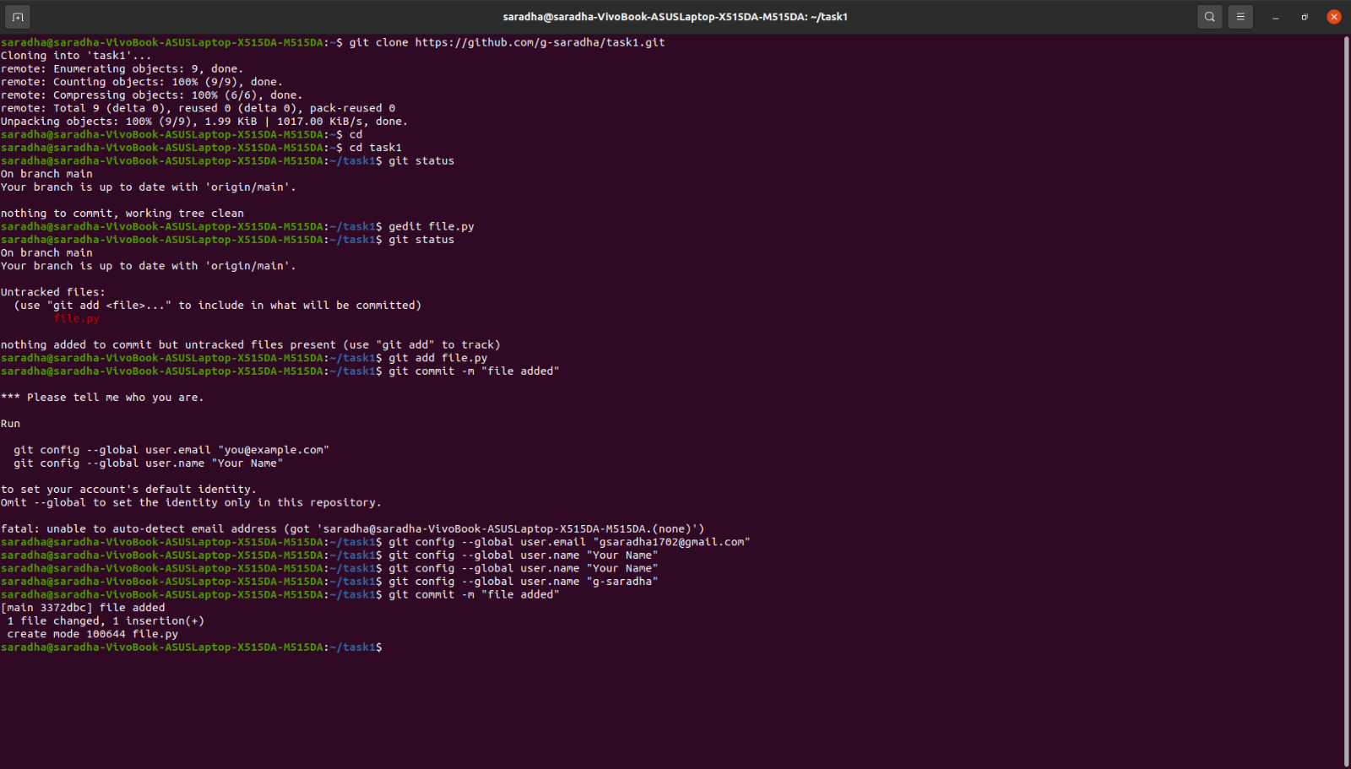

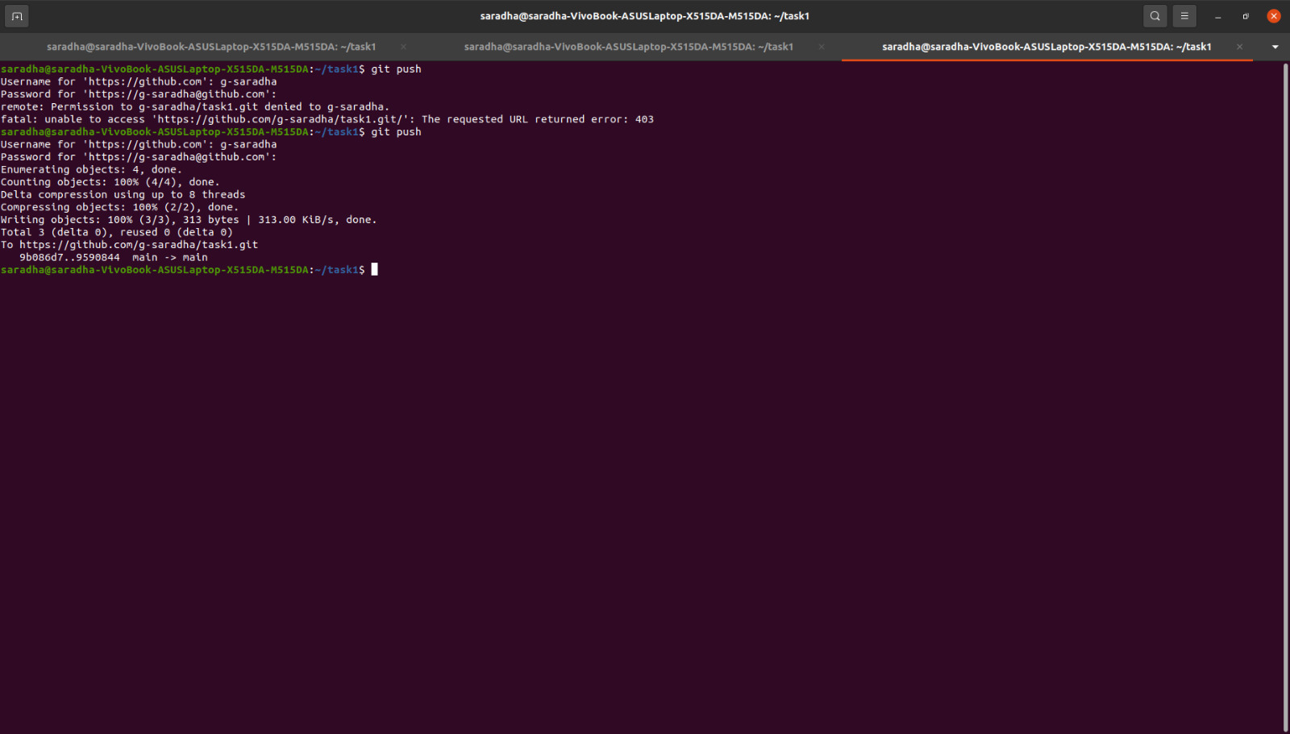

Execute these commands - git status, git diff and git log

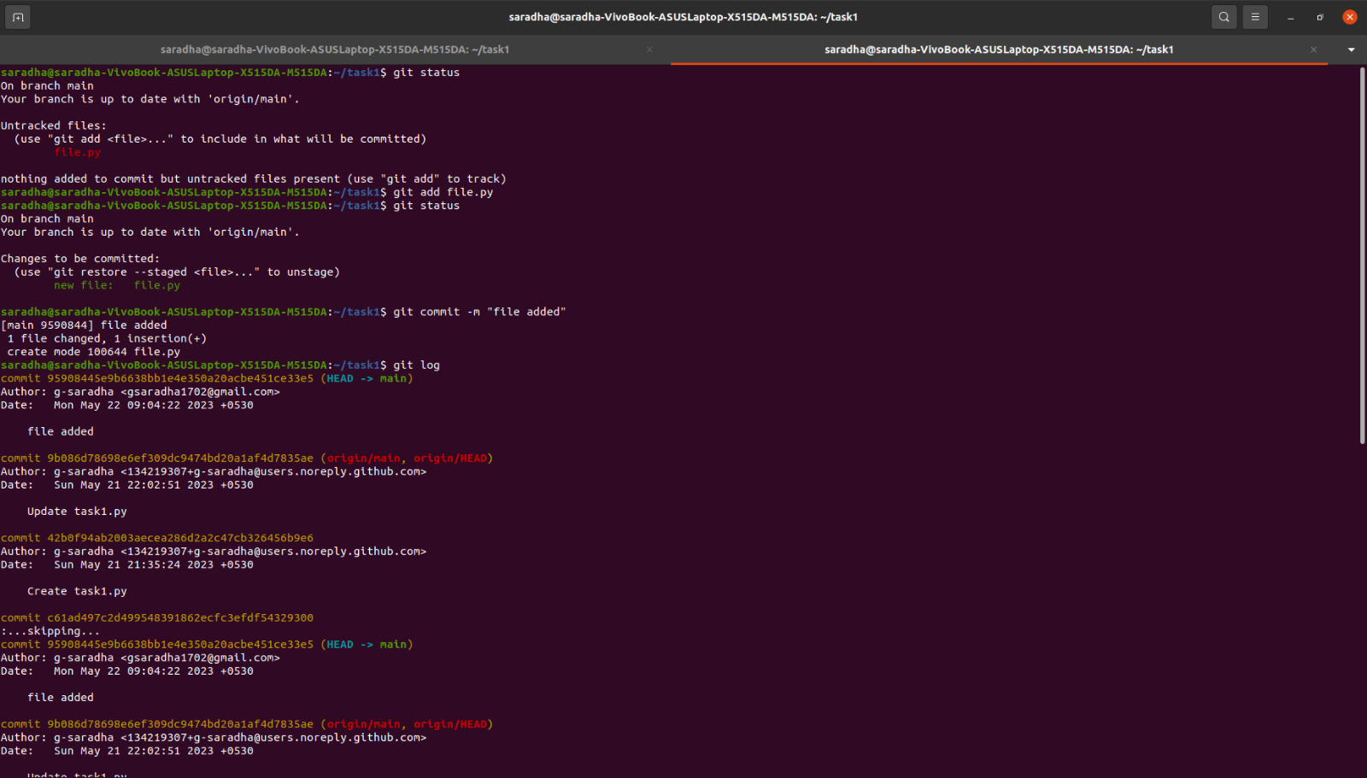

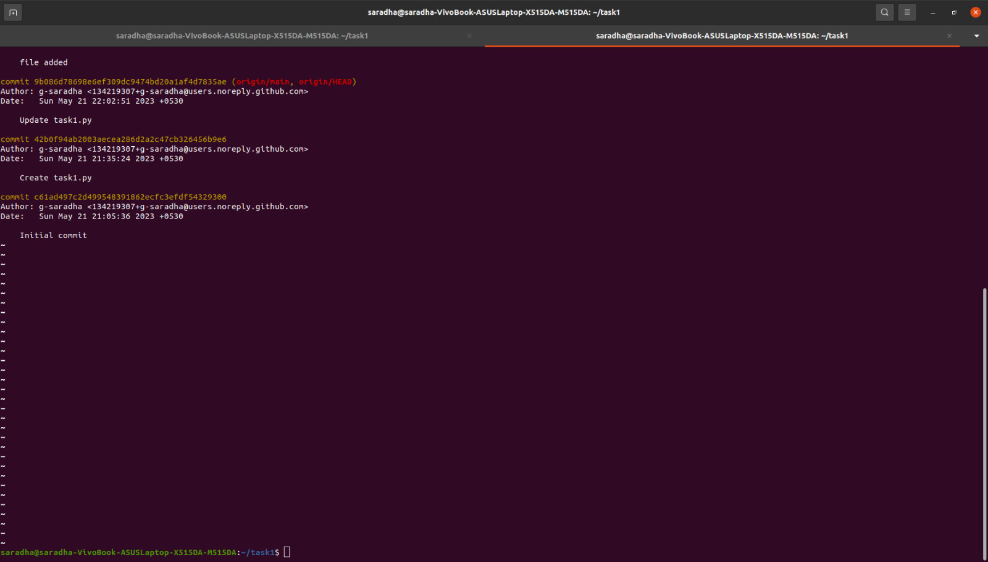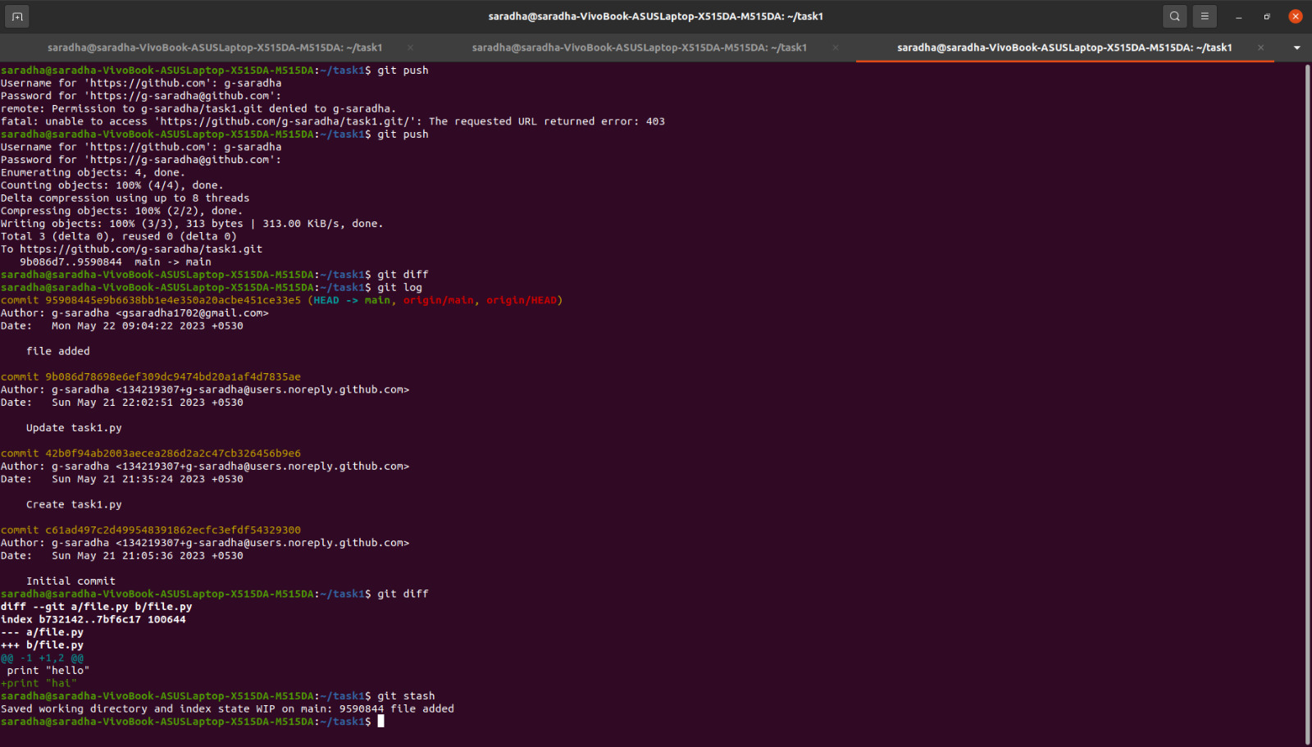

Create a branch

Checkout to that branch and make some code modifications

Then add and commit the changes while you are in the new branch

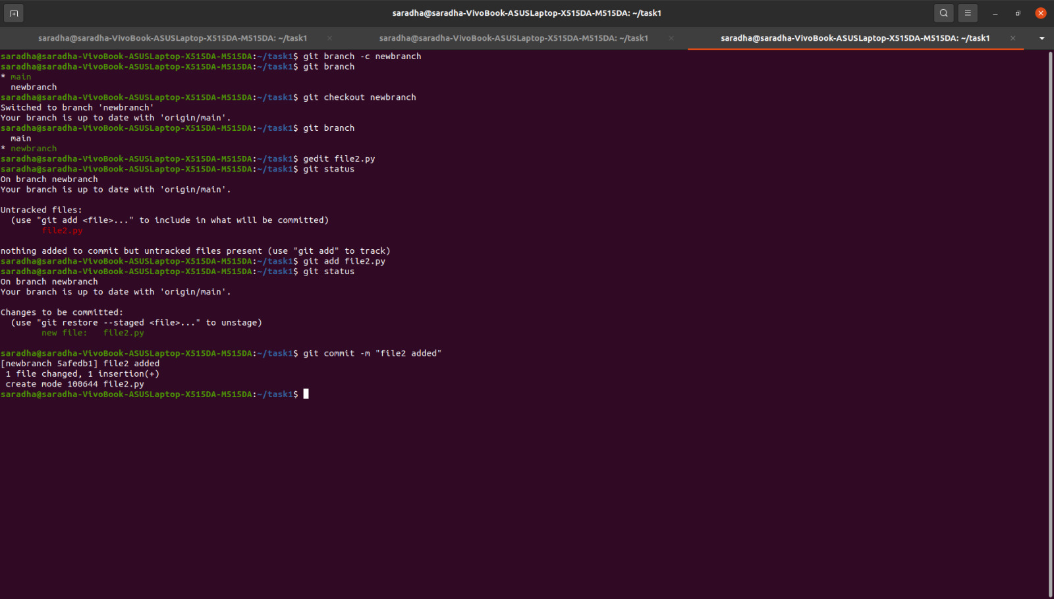

Checkout to the master branch and merge both the branches

Add, commit and push the changes to remote repo

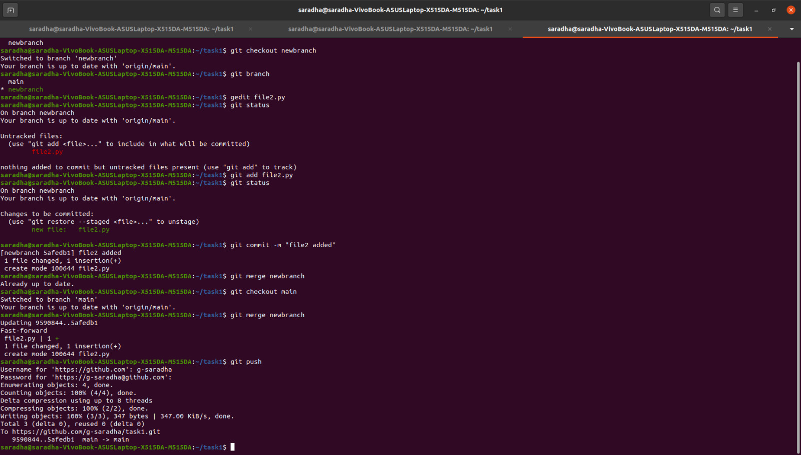

Create another branch and delete it

